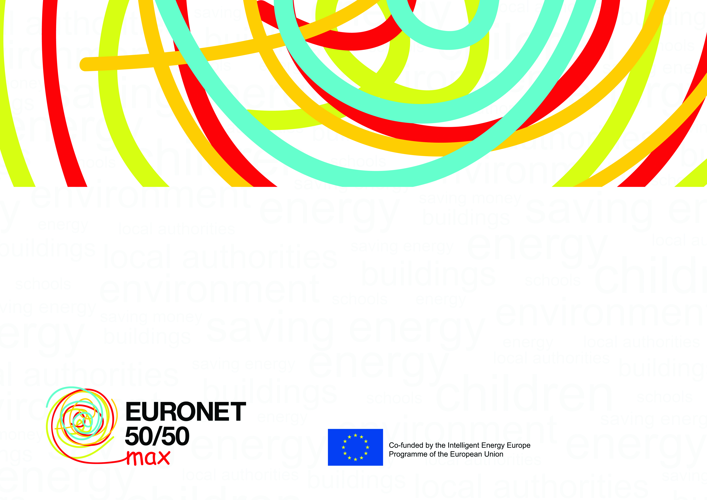

**[Name of the school / building]**

is a member of the **50/50 Network** gathering

schools and other public buildings which save energy